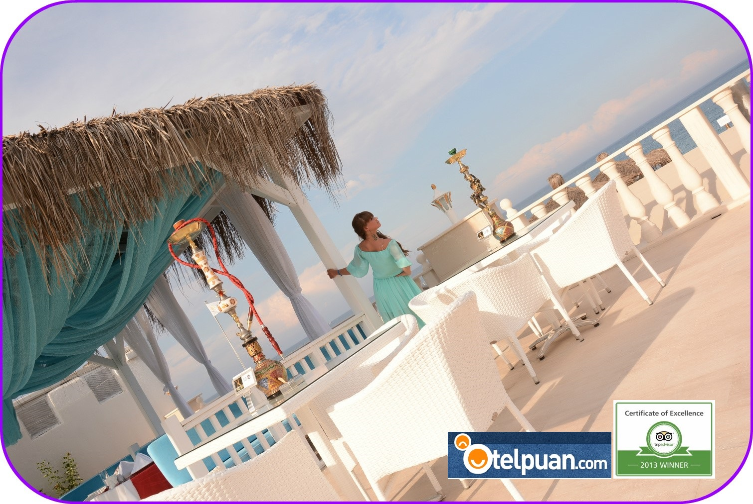
2021 SUMMER FACT SHEET

Name of the Hotel | Onkel Resort Beldibi
Year of constuction | 2010
Renovation | 2014
Area | 8000 m2
Address | Göynük Mah. Başkomutan Atatürk cad.no: 171 Beldibi /Antalya
Telephone | +90 242 824 9292
Fax. | +90 242 824 9229
Website | www.onkelresort.com
e- mail | İnfo@onkelresort.com
General Manager | gm@onkelresort.com

DISTANCE

Antalya Airport | 45 km
Antalya Centre | 32 km
Beldibi Shop Centre | 300 mt
Kemer Centre | 13 km
Bus station Kemer Antalya. | From front of the Hotel
Sea | Seaside (beach resort)

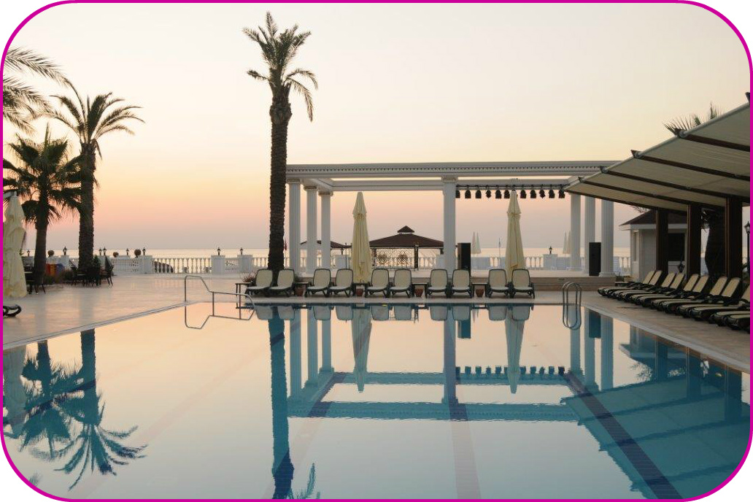
ROOMS

Number of building | Main building
Number of floor | 4
Elevator | 3
Number of rooms | 137
Number of beds | 288
Suit rooms | 6
Rooms fort he disabled | 2

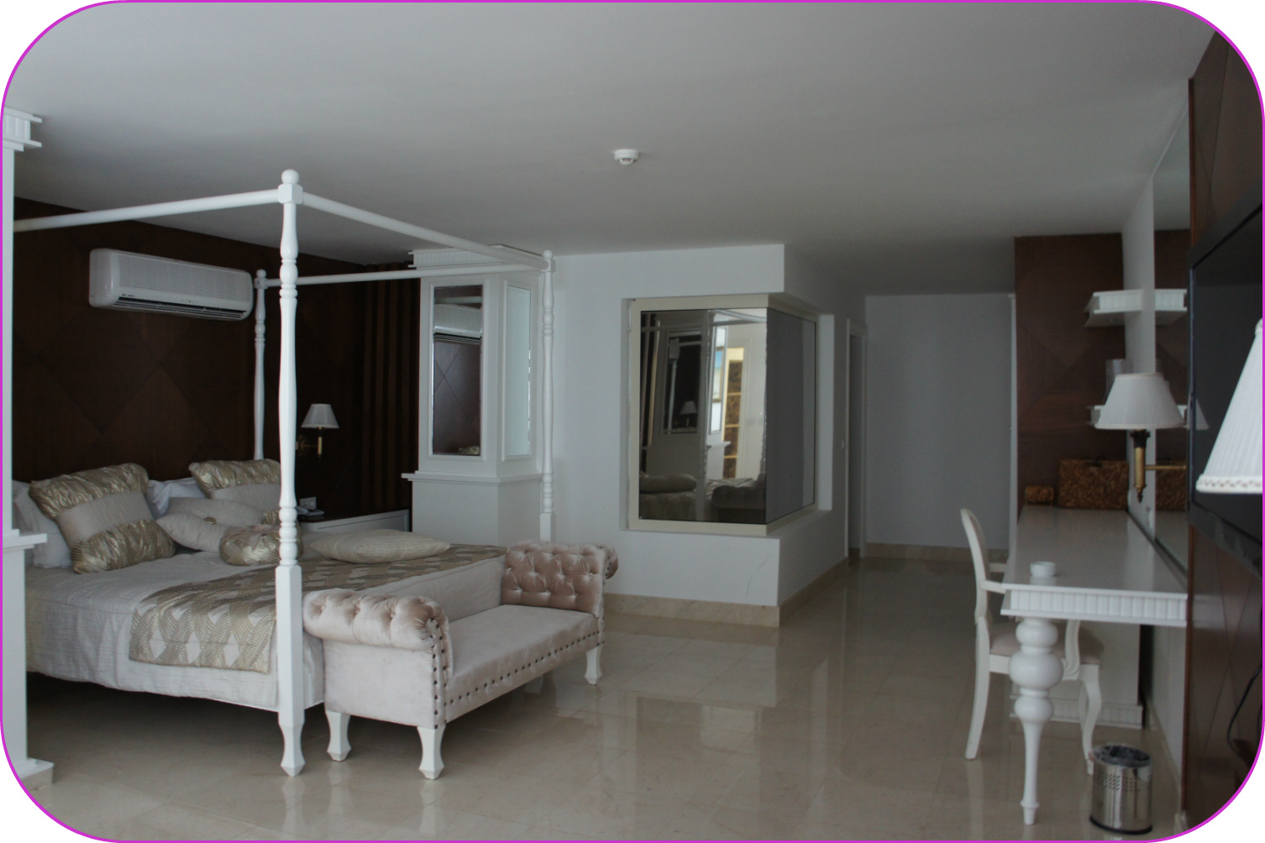

ROOM FEATURES

Lcd tv | Split air condition | 220 Vold | Shower | Hair dryer | Telefon
Mini bar | Balcony | Room Service | Safe | Satellite Tv. | Ceramic coating
Free WI-FI
Mini bar :Water for each person every day

POOLS

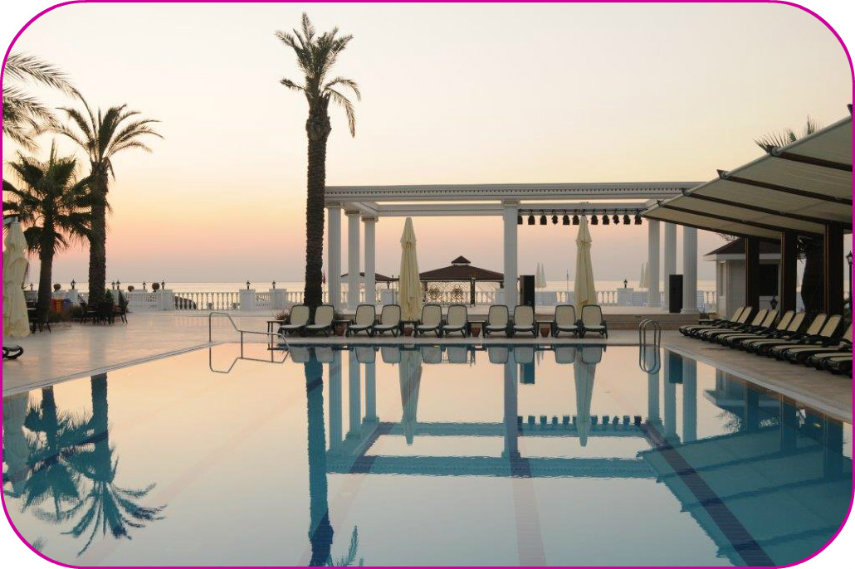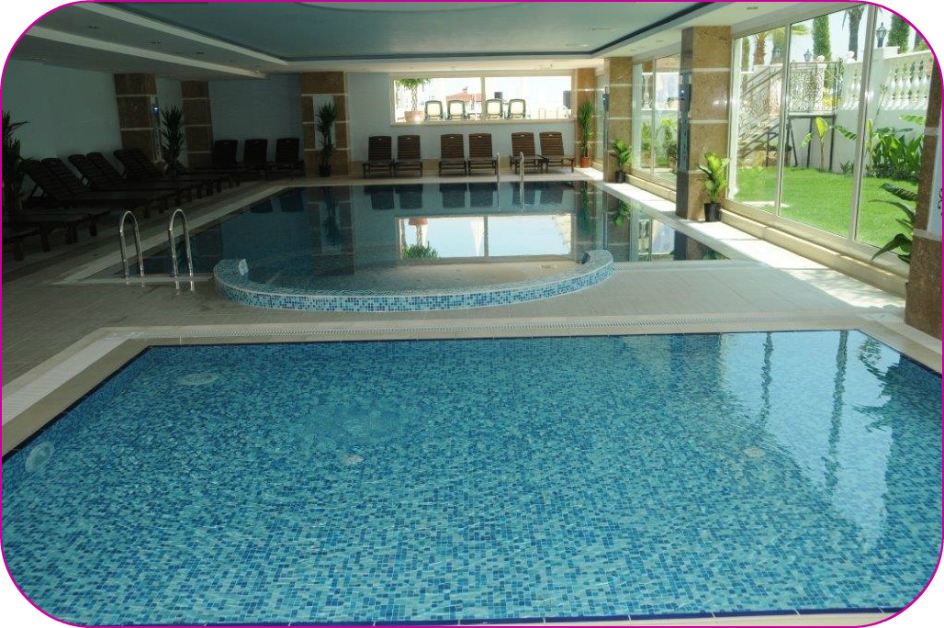

POOLS | M2 | HEATED | DEPTH(CM)
Outdoor pool | 175 |  | 165
Indoor pool | 55 | x | 140
Child pool(outdoor) | 14 |  | 40
Child pool (indoor) | 14 | x | 40
PLAJ
BEACH | 65 MT Length, Sand and Gravel
SEA PIER | Special Pier and Sun Area
CABANA | Special service charge

ALANLAR & AKTİVİTELER

 | Extra Charge | Free
Sunbeds, umbrellas |  | X
Room Service(24 hours) | X
Fitness Center (08:00-20:00) |  | X
Hamam |  | X
Sauna |  | X
Massage | X
Beauty Center | X
Hair dresser | X
SPA services | X
Wi-Fi (hotel & plaj) | X
Exchance | X
Baby cot & Baby Chair |  | X
Baggage Services |  | X
Disco ( in Kemer ) | X
Shops | X
Foto | X
Auditorium (120 pax) |  | X
Table Tennis, Aerobic, Dart |  | X
Telephone & Fax | X
Otopark Servisi |  | X
Laundry & Dry-cleaning | X
Doctor | X(by telephone)
Animation & Show |  | X
Water Sport | X
Stroller |  | X
Beach Towels | X

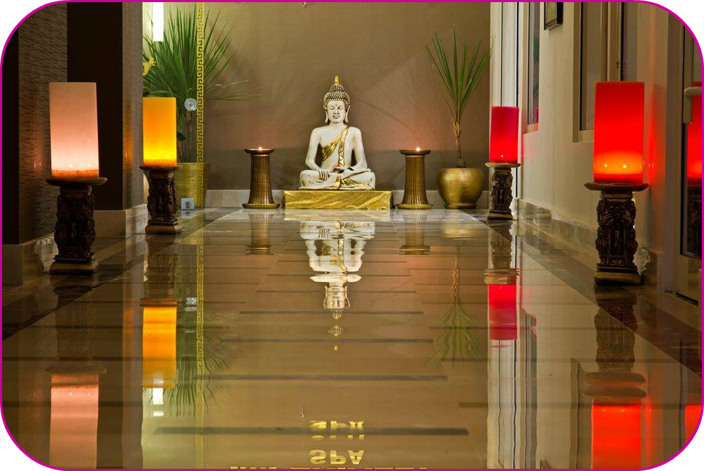

FOOD & BEVERAGE

ALL FOOD AND BEVERAGE WHICH USED IN OUR HOTEL ARE CATEGORY 1. CLASS, ALSO SERVİNG İNSPECTION OF THE FOOD ENGINEER.

RESTAURANTS AND TIMES

 | PLACE | TIMES
Buffet Local&Importı | Mood's Main Restaurant
Breakfast | Buffet | 07:00 09:30
Late Breakfast | Buffet | 09:30 10:00
Lunch | Buffet Show Büffet | 12:30 14:00
Snack bar | Alacarte service | 14:00 16:00
cookies and Cake service | Patisseria | 17:00 18:00
Dinner | Buffet Show Büffed | 19:00 21:00
Fish Restaurant |  | 19:00 21:00
Night Meal | Soups and Pies | 23:00 00:00

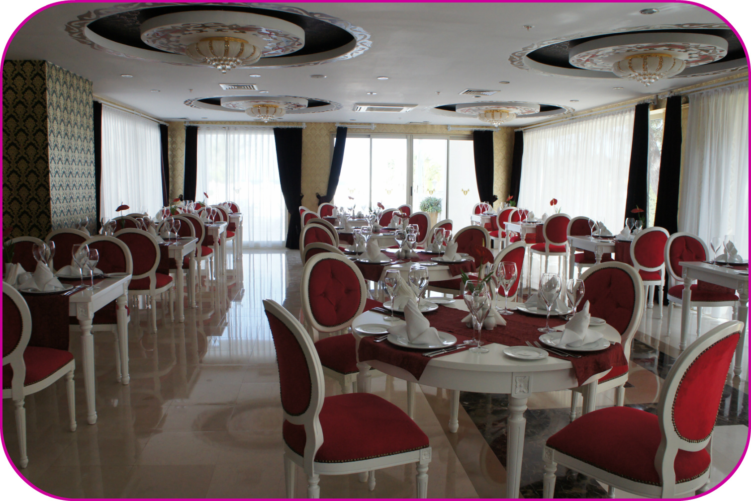

BARS AND TIMES

Lobby bar | 10:00 23:00 free
Pool bar | 10:00 23:00 free

We know that, food and drink are an important part of any stay. Whether dining in one of our innovative on-site restaurants, you’ll find delicious and accessible options to satisfy any craving
Our Team Members are always ready to provide friendly, individualized service to our guests. We’re also happy to offer a range of services to meet your needs. Keep up your workout routine at our on-site fitness centers or relax at one of our spa. From booking to checkout, we’re here to make your stay as enjoyable as possible.



