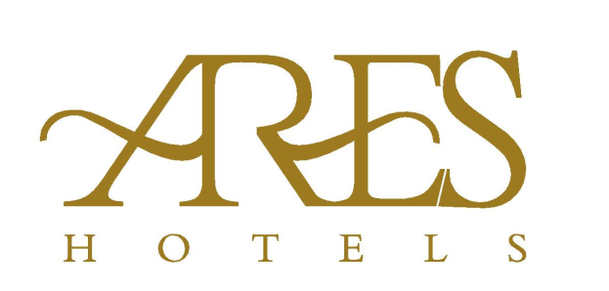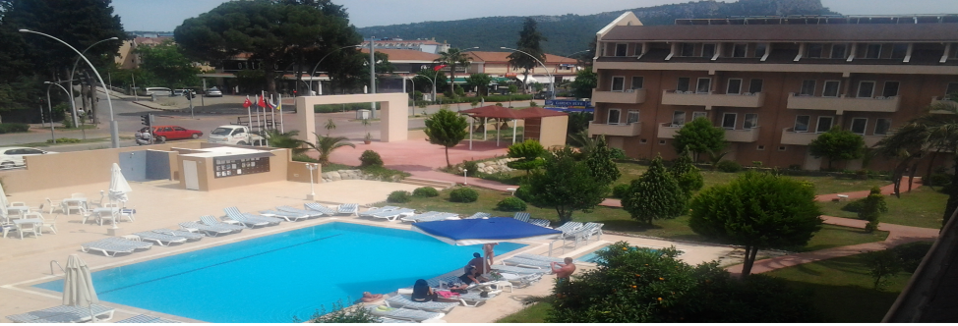

**ARES DREAM HOTEL**  **ALL INCLUSIVE**

Adres :

Yeni Mah. Atatürk Bulvarı No:39 / 1

07980 Kemer / ANTALYA

Tel. : +90.242.606 12 90

Mail : reservation@areshotels.com.tr

Web : [www.areshotels.com.tr](http://www.areshotels.com.tr)

Welcome to Ares Dream  where you can find the peace, confort ,natural beauty , and the best of hospitality.

 Our hotel is built on 4500 sqmt of land between the orange trees and flowers which will carry you to a peaceful holiday through a secret garden in the center of Kemer. At Ares Dream  ; which is located between the natural gifts , you will have the opportunity to have peaceful and relaxing holiday but still be in the city center.  
 We are located 50 km to Antalya Airport, 50 km to Antalya city center, Kemer city center , and 300 mt to the beaches. . The beach is open as of May The Hotel provides 4 star service.

**Hotel Amenities:** Our Hotel  consists of 3 blocks , 3 and 4 stories , and total of 150 standart rooms. All the rooms have TV , bathrooms , safe box, ac and 24 hrs hot water.We have  2 pools , one of them for the kids ,  and a beach bar where  you can enjoy your coctails.There are 1 restaurants at our hotel where you can taste our delicious and rich open buffet meals.Our hotel servis you with all inclusive system between 10:00 and 22:00  which **includes votka , cin , red or white wine ,Bottle of Beer  and soft drinks. Free services** : Deck chairs by the pool, umbrellas, towels and the drinks at the pool bar.

**Paid Services:** Internet (WI-FI) , bottle of beer,Turkish Coffee and drinks after 22,00 ' deck chairs and the umbrellas at the beach.

**Note : Safe Box free**

**Restaurant and Bar Service Hours**:

Breakfast             : 08:00 – 10:00

Lunch                   : 12:30 – 14:00

Coffee Break       : 16:30 – 17:00

Diner                    : 19:00 – 21:00

Pool Bar               : 10:00 – 22:00

## ****Restaurant****

We have 1 Outdoor and Indoor Restaurant and we serve you with our rich open buffet.  
Our hotel offers guests with Red and White Wine, Beer and Soft drinks options between 08:00 - 22:00 hours with our all inclusive system.

Our Free Services; Deck chairs, umbrellas by the pool, alcoholic and non-alcoholic beverages in the pool bar.

Our Paid Services:  
Safe (in the room), Internet: in the open areas and in the rooms, Turkish Bath, Hookah, Turkish Coffee, and beverages from the poolside after 22:00, Beach chairs, umbrellas.

# ****Bar****

You can sip your drink in our pool bar and enjoy your drink in the summer. Our Free Services; Deck chairs, umbrellas by the pool, alcoholic and non-alcoholic beverages in the pool bar.Our hotel offers guests all kinds of services between 10:00 - 22:00 hours and offers guests Red Wine, White Wine, Beer and Soft drinks.

**Pool and Beach**

There is 2 outdoor swimming pool and 1 child swimming pool and you can sip on our pool bar and enjoy your drink in summer. Plaj is 300 meters away.

**ANIMATION**

01.05.2020 – 30.09.2020